**2020 Leaving Certificate Paper HL**

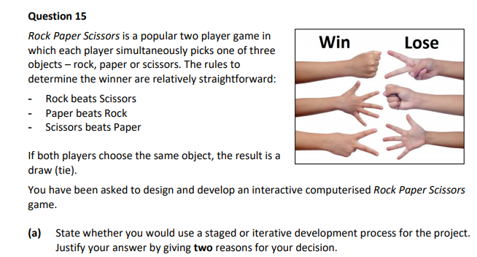

| **Staged or Iterative** |
| --- |
| **Reason 1:** |
|  |
|  |
|  |
|  |
|  |
|  |
| **Reason 2:** |
|  |
|  |
|  |
|  |
|  |
|  |

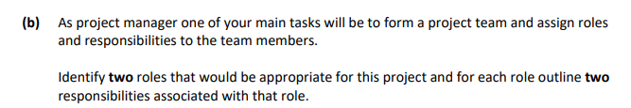

| **Role 1:** |
| --- |
|  |
| **Responsibility 1:** |
|  |
|  |
|  |
| **Responsibility 2:** |
|  |
|  |
|  |

| **Role 2:** |
| --- |
|  |
| **Responsibility 1:** |
|  |
|  |
|  |
| **Responsibility 2:** |
|  |
|  |
|  |

**2019 Sample Paper OL**

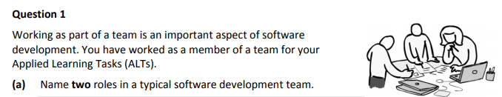

| **1.** |
| --- |
|  |
| **2.** |
|  |

**(b)** List **one** advantage of working in a software development team

|  |
| --- |
|  |
|  |